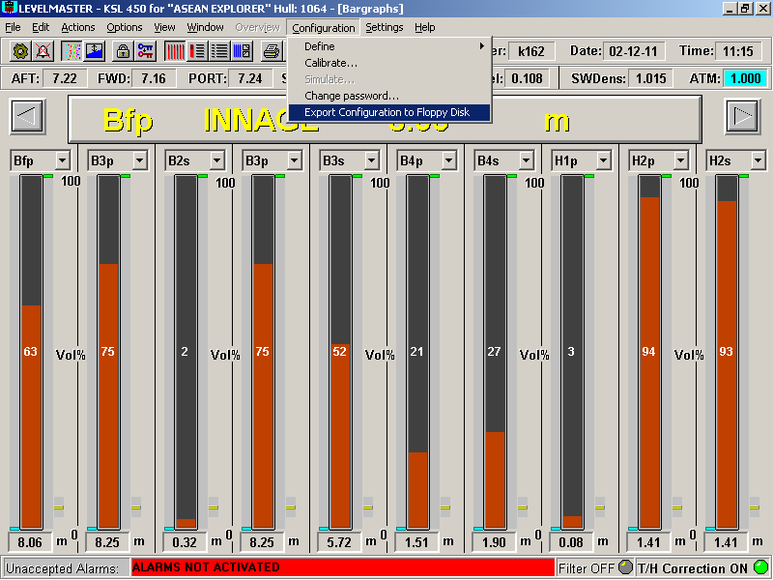

Select the “Export Configuration to Floppy Disk” on the Configuration menu

